Localization of Software for small business

Subject Name: Software Internationalization
Subject Code: ITN770

Student: Ran CHENG (n5105269)
Student: Yue Zhou (n5105765)

Table of Content
1. Introduction 3
2. Background 4
3. Case Study (Current state) 5
4. Issues and Solutions 6
4.1 The work to the public 6
4.1.1 Dedicated official website 6
4.1.2 Dedicated localization websites 7
4.2 The standard three steps to localize 8
4.2.1 Identify localisable resource: 8
4.2.2 Well designed API 9
4.2.3 Easy access 9
5 Future work 9
6. Reference 10

Table of Figure
Pic. 1 Plug-ins description from www.winamp.com 4
Pic. 2 List of latest localized updates from www.hanzify.org 5
Pic. 3 Tutorial list of localization from www.hanzify.org 5

Introduction
“Internationalization or “I18N”is the process of designing an application so that it can be adapted to various languages and regions without engineering changes.” “Localization or "L10N" is the process of adapting a product or service to a particular language, culture, and desired local look-and-feel.” I18N is L10N done in a systematic fashion and in essence I18N is L10N done well. More general, I18N and L10N are means of adapting products (not only for application anymore) for non-native environments, especially other nations and cultures. Culture dependent information includes language, calendar, string comparison and sort orders, data and time formats, currency and number formats, writing system and case conversion, paper size, measurement units, addressing conventions and so on. “Small business may be defined as a business with a small number of employees. The legal definition of "small" often varies by country and industry, but is generally under 100 employees. These businesses are normally privately owned corporations, partnerships, or sole proprietorships.”

Software internationalization is very challenging; particularly the i18n is not planed and designed from the beginning. Software i18n is hard for the hard, and even harder for small business, since the small business don’t have enough resources. However as the economic become globalise, development international wide software is getting essential. So a compromise of software I18N for small business is software L10N.

In this report, we focus on the software l10n for small business from the IT professional perspective. We will give some background information about the software i10n and small business in background section, list some research result regarding to the current state of topic in ongoing state section, and discuss some issue and solutions in the Technique issue section and solution respectively.

Background
As the time goes on, traditional business logic is getting changed. The domestic only business strategy are not suitable for the current market any more. Most of the companies are start thinking or already started doing international business. Especially, in IT area, a lot of products, like software application, can be shipped through internet without any shipping cost, which makes their business development much easier to the international market. Here we focus on the software market.

One of the major issues of selling software at international market is software i18n. We did some search regarding to the history software i18n, but can’t find any official record for that. Anyway, software i18n is one of the hottest topics in software development field. Because l18n is such a hard task to do, not every firm whose software is already internationalised do the l18n in a systematic way. Instead, they use software l10n fashion, which means the software they offer has the localizability.

Since the software l18n is so hard, why should the software company still internationalise their software? According to the study, more than 85 percents of IT companies in Australia are small business and most of the firms are micro businesses (Under 15 employees). Expend the research to world wide, the percents may vary, but the small businesses still have large occupation. By searching on the Internet, most shareware or freeware are produced by small firm even studios which consist of a couple of people. As shown, small business are playing very important role in the entire market, and just because of that, the software i18n must get the small business involved. On the other hand, when users select the software, most of them don’t really care about who is the producer; what they only care is whether the software is suitable to their use. In other words, the users won’t give any special consideration to the small business regarding to suitability. So to let the software suitable to the international market, small business must be ready for i18n.

Case Study (Current state)
“Before Apple iTune was born to world, which is your favorite multimedia player? If I mention Winamp here, you will remember it was one of the most downloaded pieces of software for windows operating system when the first version released in 1997. I also remember it brought the idea of skin changeable which is one of the important features for being localizable. Actually, Winamp never have other languages edition officially. But it was used by the world. How?” asked by one of my friends. After that, my own Simplified Chinese version of Winamp came to world. 10 years past, Winamp now supported by AOL and maintained by Nullsoft. It still does not have other language version except English. But you can find more than 11 other languages (www.winamp.com) plug-ins can be downloaded from its website, but not maintained officially. They all works like new skin plus a translated resource file.

Before it enables this changeable feature, what users can do is use some tools, like eXeScope (eXeScope is a program that allows to modify the texts and images that appear in an application) to identify the strings and replace the translated one directly in .exe file. And use an image editor to modify the text on the skin pictures. This work can be done by any other users easily, even they do not know how to coding. When localization can be afforded by a normal user, the internationalization workload could be distributed to customers all over the world, which could reduce the cost of internationalized work of the software author. So, the localizable feature becomes the most important one of shareware or tiny software, which is released by a single author or a small team who want to broadcast their products to the world.

Early version of Winamp doesn’t have any localisable feature. The people want to localise the software must unshell the core of this programme, and grab the string and replace with other ASCII character sets. This type set must be the same as the platform; otherwise the character could not be displayed. After Unicode come to world, the Winamp developer changed the programme to Unicode compatible. The characters are able to be displayed platform independently. At meanwhile, the concept of plug-in for language package was introduced in Winamp version 2.8. Localizability becomes very easy. At present, the localizable resources of Winamp include skin, string, layout and visual effect. Actually, the current version of Winamp has reached the high level of Localization, but the developers still don’t try to release multiple language version. In this way, they reduce the cost, and don’t need culture specific staff to maintain the software.

Winamp story shows us the standard software l10n flow, from nothing, to some feature, and eventually to the high level l10n.

Issues and Solutions

The work to the public
Internationalization is expensive for a single author or small team. It is caused by not only the limits of bilingual ability but also protracted project life. There are recommended way to distract the work to users.

Dedicated official website
As mentioned above, the translated version can be easily created by user, but it may hard to get by others. Like Winamp, they supply dedicated server to hold the plug-ins from fans to let other users reach these resource easily. This behavior can not only monitor the quality of localization, but also increase the visiting counts which could bring another income. For an instance, the picture below gives downloads and ratings of a Russian version which could be an important index of the quality of the translation.

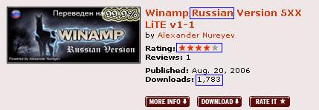
Pic. 1 Plug-ins description from www.winamp.com

Dedicated localization websites
Shareware or tiny software is a large part of software and often is the foreland of new technology and application. They are cheaper and easily touched and tried before purchase. They update frequently which increase the difficulty for internationalization. A dedicated translator for a particular piece of software could be much more efficient because this translator hold the translation memory for this software. Otherwise, share translation memory is also a good way to increase the efficiency and quality of translation. A dedicated localization website is available for a group of translators to share translation memory is necessary. For an instance, one of the dedicated localization website www.hanzify.org for Simplified Chinese language organizes more than 6,000 localization projects. The picture shows the recent update items, which are classified by categories.

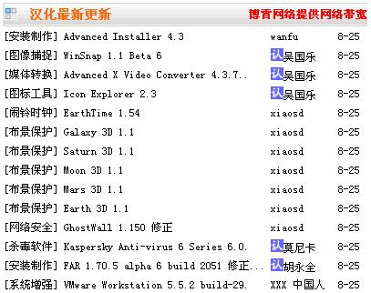
Pic. 2 List of latest localized updates from www.hanzify.org

It also supplies tutorials for translating and repackaging by variety tools. Like Trados, Alchemy Catalyst, Passolo, etc.

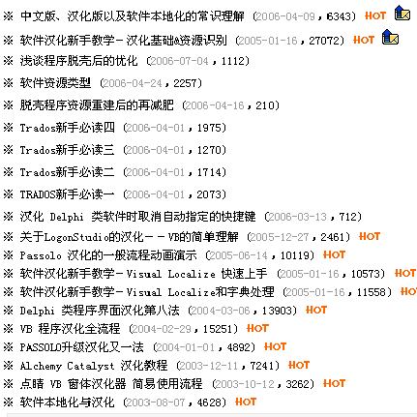
Pic. 3 Tutorial list of localization from www.hanzify.org

The standard three steps to localize
The high localizability seemed to be the most important feature their products should have. The availability of a well-designed API is necessary for easily localized software. What are the features l10n should have?

Identify localisable resource:
The first step is the identification of localizable resource. It is ideally to separate all the resource from code. But some times, it seemed expensive when the software has large pieces of resource could be reused. So, list the resource to be localizable only when it is needed to be.

Well designed API
Supply a well-designed API could be reduced the difficulty for localization dramatically. XUL seemed one of the possible solutions for that. XUL, pronounced as /zool/, stands for "XML-based User Interface Language", is a cross platform way of describing user interface. In reality, a typical XUL file may contain standard XML (eXtensible Markup Language) elements, XUL specific elements, style information (currently Cascading Style Sheets), HTML (HyperText Markup Language), and JavaScript functions (Matejka). The most successful story is Mozilla project. Some companies may have their special format but based on the same principle. A technical manual or tutorial is friendly for the contributors for your localization work.

Easy access
As mentioned above, a dedicated website not only could be efficient way to monitor the process and quality of localization conducted by public, but also a platform let the contributor communication with each other and discuss the technical problem.

Future work
There are a lot of different ways to achieve software l10n; some companies even have their own way to do it. Just because too many approach available, software developer find it hard to select and inter-operate with each other. One industry standard is required for software l10n, and actually, some organizations have started working on it, such as LISA, The Localization Industry Standards Association.

6. Reference

Java i18n Tutorial, http://java.sun.com/docs/books/tutorial/i18n/intro/index.html (accessed on Aug 18, 2006)
Bitpip.com, http://bitpipe.com/tlist/Localization.html (accessed on Aug 20, 2006)
ITN770 Lecture Note Week 1, slide 20, Jim Hogan. Semester 2, 2006.
Wikipedia Internationalization and localization, http://en.wikipedia.org/wiki/Software_localization#_note-0 (accessed on Aug 20, 2006)
ITN770 Lecture Note Week 1, side 36, Jim Hogan. Semester 2, 2006.
Wikipedia Small business, http://en.wikipedia.org/wiki/Small_business (accessed on Aug 20, 2006)
Winamp.com, http://www.winamp.com/plugins/browse.php?category=9 (accessed on Aug 25, 2006)
Useful utilities, http://en.utilidades-utiles.com/download-exescope.html (accessed on Aug 27, 2006)
Hanzify.com, http://www.hanzify.org/ and http://teach.hanzify.org/index.php?Go=Special::6 (accessed on Aug 25, 2006)
Matejka, Daniel. XUI Language Spec. http://www.mozilla.org/xpfe/languageSpec.html (accessed on 28 August)

